What issue or issues are you focusing on (Please no more than 1 or 2)
The issue of women education and gender disparity in the East Africa region
Globally, education has now been embraced as one of the most vital and core things in human existence. The impact of education has been widely felt and every country across the world has set the system right to ensure its citizens acquire proper education. However as much this has been the prime goal of every nation and state in the world, the question of women education has always raised an issue in the East Africa region. across many countries in East Africa, the status of women’s education remains a disgrace and a shock for that matter. Statics have shown that a girl who is South Sudan more likely to die during birth than to finish primary school. It is also shocking that in Somali, only 3% of the girls attend secondary school. Whichever the reason may be, east Africa has experienced this crisis of having very few women having access to education.
The reasons why most girls are not accessing education may be complex and very diverse due to the difference in culture religious beliefs and even marginal cases. Without complete proper education, women are not able to cater for their family’s and their own needs. despite many focus and challenges that have been made to ensure a girl child gets an education, the crisis is still at epic and profoundly visible. The challenges that the girl child has been experiencing include pressure to fulfill traditional roles as housekeepers and mothers rather than going to school, early and forced marriages to increase when poor families are in dire need of money and female genital mutilation are still being practiced in east African countries.
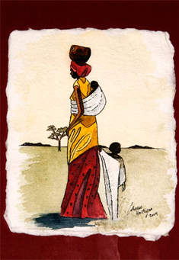
Women education in a country such as Kenya has also been interrupted and corrupted by sexual violence against girls and women. In east Africa, sexual violence is one of the common forms of violence.
Also, countries in East Africa have recorded an incident where boy child education has been seen as a priority and a suitable child. The argument in this nation has been that the resources have been dismal thus increasing the need to choose to educate a boy child and taking dowry for
the girl child. The gender role dictated by the culture has also had a great sense of impact on the education of a girl child. As such, the girl in Uganda, for instance, is supposed to complete household chores and take care of their younger siblings.

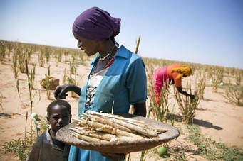
The question of the woman in east Africa being denied access for education is simply an indication of gender disparity. The disparity of boys and girls starts right away in primary school but the society or the culture of the community in many different ways propagate in widening the gap through the entire education system .looking at the actual number of girls being enrolled in most schools in the East African region, the number has been very low and raising a serious concern on the issue of women education in the region.
Who is affected by the issue (individuals or groups and who/where they are.
In this crisis, women in east Africa are the ones affected. On the issue of education, the number of women who have not acquired education is very high posing a stern concern. Opportunities for women to acquired education in this region is has been very narrow. The priority has been given to the boy child thus increasing the possibility of a girl child denied education rights. Despite huge efforts of the government to handle the issue of women education in countries within the region, the challenge has been cultural differences, cultural beliefs, and low economic standards. Due to poverty in most of the countries in this region, in a situation where a family has many children, girls are the first to be denied schooling opportunities. Also, women are seen as subjects of household chores and taking care of homes. Therefore, they are highly shorn of education unlike boys who are allowed to get in the education system and parents hold great expectations in them.
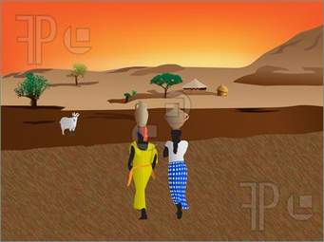
The issue of gender disparity has also affected women greatly. the boy child being given the priority in accessing education possess an eyebrow. they have been given very minimal access to government operation, political arena, and business world. This has kept women at a high ladder of gender disparity.
What are the important facts/stats to know about this issue as it affects your culture or group
Knowing about the issue of gender disparity and woman education would help in several ways. First, the knowledge will help reawaken an individual in helping to gap the gender disparity gap and also help to promote the education of women. By understanding the environment of gender in an individual culture or group, a great step will follow to eradicate the gender disparity by advocating female education and involvement.
The information obtained would also be used in educating people on the risks and dangers of gender disparity and how a nation would be doomed if it only focuses on male education and neglect female education. The information would also be used to draw a red line in the campaign against gender disparity. the strength of understanding what an educated woman can do will initiate a concern to call for the rights of females on education.
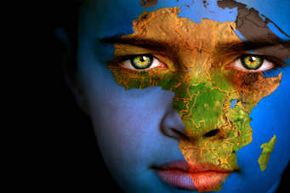
Besides, having the concept of the issue of gender disparity would ignite the passion to embrace gender rules and affirmative actions. The power of such information would also be a key tool in fighting gender-based violence.
Is any government or agency involved to address the issue or issues1
However, much woman education and gender disparity have raised an alarm and taken to be a serious issue in the East African region, credit should be given to most governments in the region for their incredible decision in focusing to change the image of female education and challenges of gender disparity. Apart from the government, some agencies have also had sleepless nights to ensure the issue of gender disparity is no longer a black ship in east Africa.
The governments in Kenya, for instance, issued an order to all secondary schools to ensure that there is a balanced ratio of male and female teachers. The government in Tanzania allowed vast women participation in the political arena and the government in Uganda for the removal of post and burners that promote gender disparity in the country. These notable steps by the government have a hard huge impact on the changing of gender image in the region and in promoting female education. The agency such as NGOs has also helped widely in promoting female education and curbing gender disparity in the East Africa region by providing educational services and policies. Many NGOs have provided education sponsorship to many girls in marginalized areas and those from poor families.
How do the local people view the issue
Over the years the issue of women's education and gender disparity has been a bother and key concern to the people of East Africa. They are however aware of how gender disparity has corroded the ultimate passion of growth and development in the region. moreover, the battle to ensure there is strict observance of gender and education has not been a walk in the pack. Several efforts have been put to measure that women access education and no gender disparity cases.
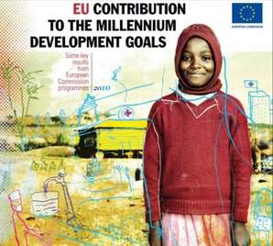
Consequently, the view of gender disparity has been changing due to the mass campaign on the importance of education to both women and men. there is evidence of a negative attitude on the education of women among the people of East Africa. Most of them view the education of women as still west of resources and time. due to much inculturation of Africanism, many suggest and sights the education of a girl child as not important at all.
The measure of the ideology of the people of East Africa about the factor of gender disparity is still a complex nut to crack. They have shown inconsistency in the view and opinion about the same thus posing difficulty to be understood on this subject.
Is their international attention on the issue or issues for your culture or group
Despite the issue being very serious and logically worth attention, it has had a little attention in the global sphere. though the United Nations has shown a minimal concerning major step has been seen as far as the gender disparity in east Africa is concerned. suggestion by significant international leaders has been echoed by many people on the need to attend seriously on the issues. However, the convention on the elimination of all forms of discrimination against women (CEDAW) has boomed their statute by making people realize the rights and freedom of women from discrimination. they have been able to advocate on the need to respect women by allowing them to access their integral rights such as that of access to education. In their argument, they have also passed across a great need to understand the impact of empowering women for better building of families.
What are the possible solutions to the issue? Is there any impact or implementation?
Since education is one of the key tools for national development. Serious consideration should be taken and solutions fetched widely to ensure that the issue of education of women and gender disparity is handled. Some of the possible solutions to these issues include eradication of poverty woman empowerment, woman involvement, and participation
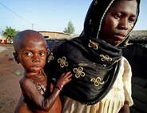
The governments in East African countries should focus on I regular review of the curriculum to reflect a gender-sensitive education system. Another possible solution would be of allowing or government to ensure more gender-related courses are added in the university curriculum or programs. Also, more bursary, scholarship, and affirmative action on girl child and more girl schools established especially in arid and semi-arid areas.

